No. | Answer
 | It was necessary to dry it so that water did not add any mass to the compound. Grinding it helped it to dissolve.
 | n((NH₄)₂SO₄) = 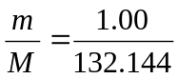 = 7.57 × 10^{–3} mol
 | Between steps 5 and 6, additional filtration with washing of the residue would have been required to remove the insoluble components.
Ba²⁺(aq) + SO₄^{2–}(aq) → BaSO₄(s)
If the fertiliser was pure:
n(BaCl₂) needed = n(Ba²⁺) = n(SO₄^{2–}) = n((NH₄)₂SO₄) = 7.567 × 10^{–3} mol
V(BaCl₂) = 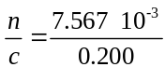 = 0.0378 L = 37.8 mL
 | The precipitating agent should be in excess to ensure complete precipitation.
 | The supernatant liquid (filtrate) was tested with BaCl₂ solution. No precipitate was observed.
 | Heat helps larger crystals of BaSO₄ form so it is better to wash it in hot water than cold. Washing removes any ions adsorbed onto the surface of the precipitate.
 | This means that the precipitate was dried, weighed, then dried and weighed again. If the masses are the same, then constant mass has been achieved and there is no more water present.
n(BaSO₄) = 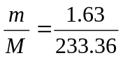 = 6.985 × 10^{–3} mol = n(SO₄^{2–}) = n((NH₄)₂SO₄)
m((NH₄)₂SO₄) = n × M = 6.985 × 10^{–3} × 132.144 = 0.9230 g
% m/m ((NH₄)₂SO₄) = 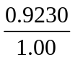 × 100 = 92.3%
• Errors in weighing
• Incomplete dissolving of fertiliser
• Incomplete precipitation
• Losses due to filtration
• Not completely drying the precipitate

